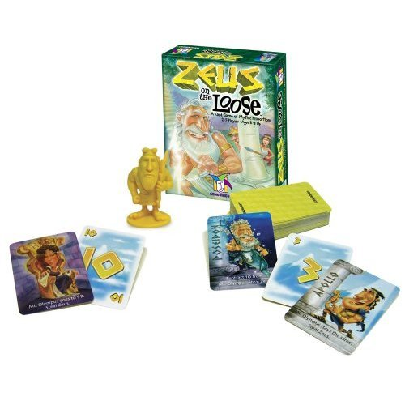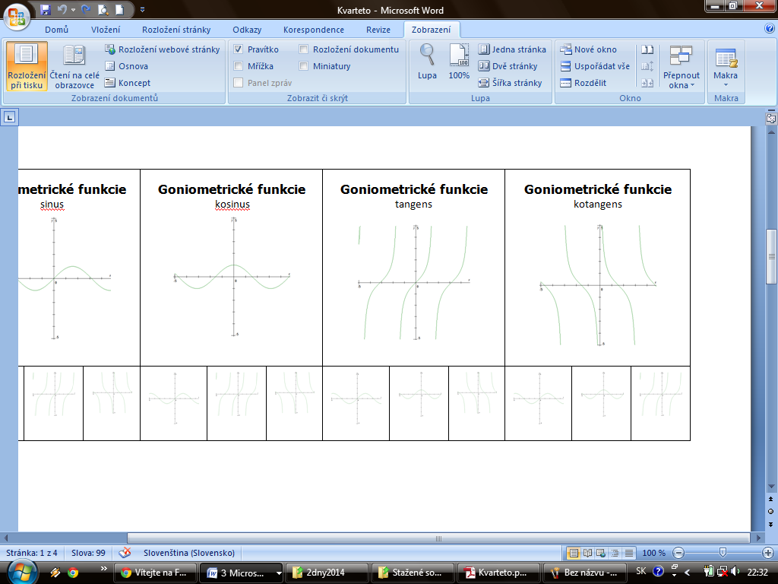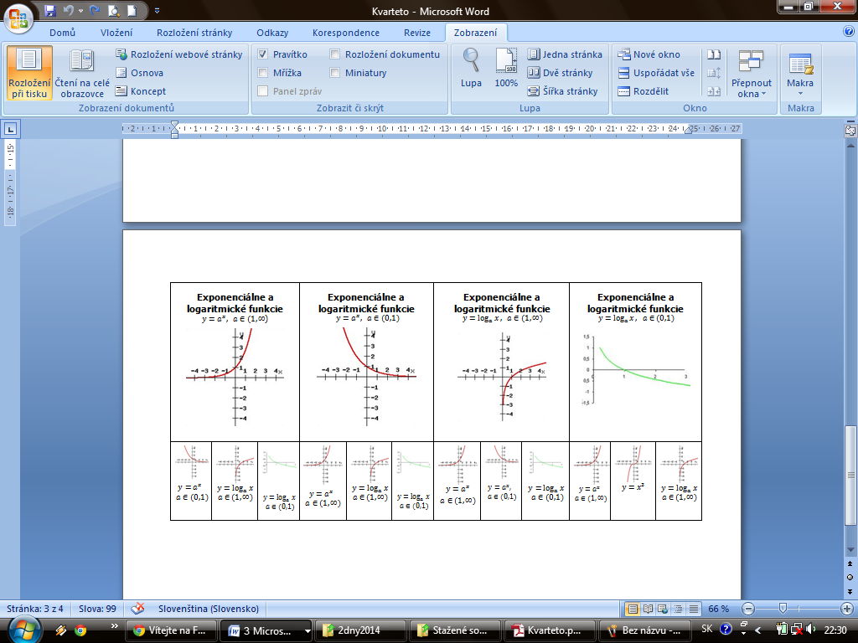

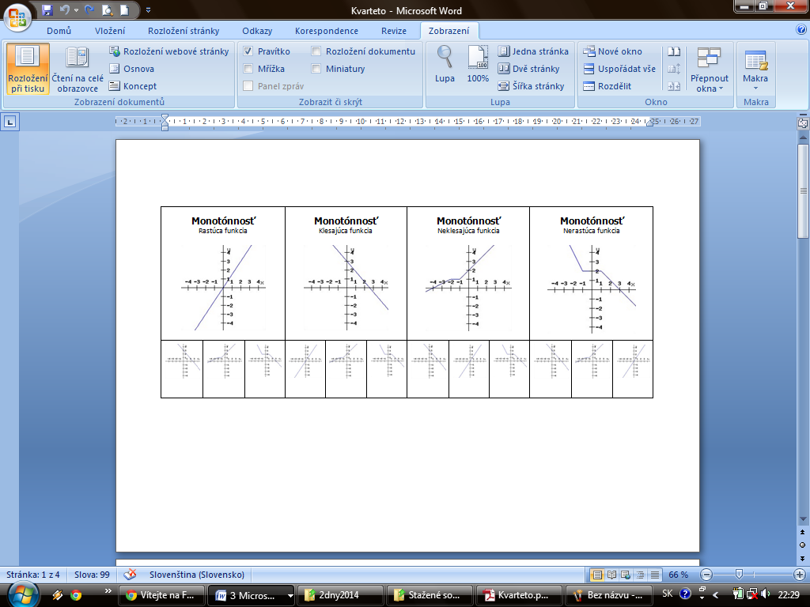

**Games in Mathematic´s Lessons**

2014

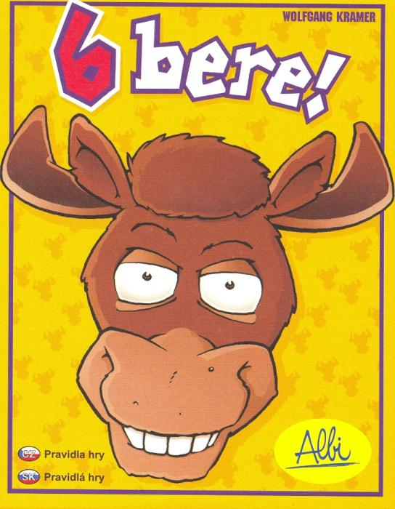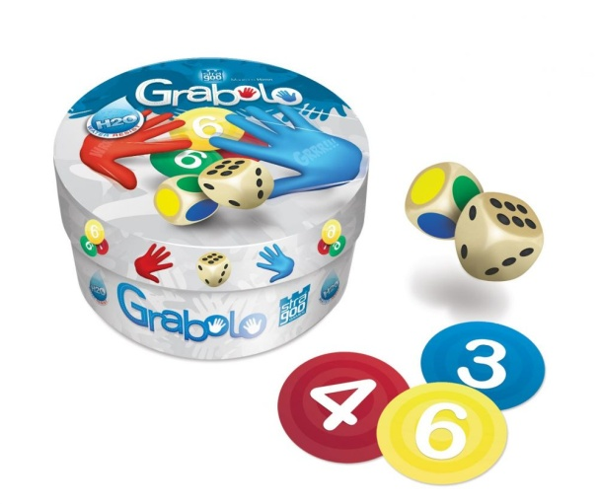

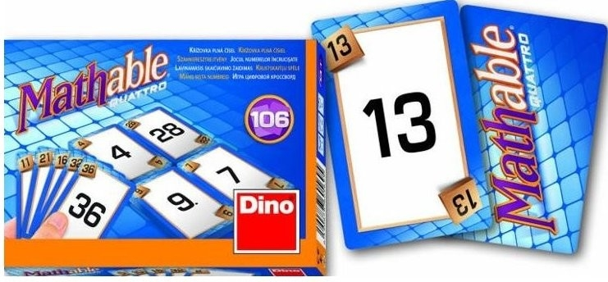

Mária Beniačiková

Alžbeta Brišová

Miriam Dubovská

Mathematics Department

Faculty of Natural Sciences

University of Matej Bel in Banská Bystrica

Daniela Guffová

Michaela Chvojková

Elena Murinová

**List of Games:**

Math Quartet 3

Mathable Quattro 4

Zeus on the loose 5

6 nimmt! (Take 5!) 6

SushiZock im Gockelwok 7

Mathematical Ludo 8

Ludo with Multiplication 10

Mathematical Memory Game 11

Math Dobble 12

Catch Me! 14

Swish 15

Continuo 16

Grabolo 17

Scopa 18

Game Tips 19

# Math Quartet

**Number of players:** 3-6

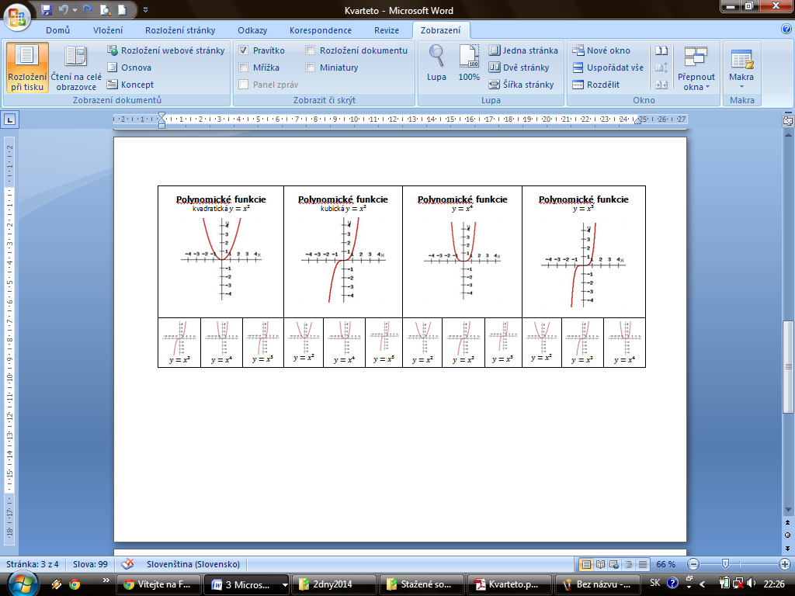**Tools**: Game Math Quartet consists of 32 cards. The cards are divided into eight groups of four cards so that in each foursome one topic prevails. These foursomes are referred to as quartets. Each card illustrates the other 3 cards of its quartet. The player gains 1 point for every complete quartet.

**Aim:** To get more points (quartets) than the other players.

**Rules and game course:**

All cards will be distributed, if possible evenly among all the players. Some players may have one more card than the others (if uniformity cannot be achieved). The player (P1), who starts the game, asks any other player (P2) to give him the card which (s)he describes. If the asked player (P2) has the reported card, (s)he gives it to the asking player and the same player (P1) continues polling cards from any teammate. Otherwise, the right to ask for cards is given to the asked player (P2). The complete set of foursomes is put aside. The game continues to be played in this pattern until all the foursomes are complete.

**Target group:** Secondary school students.

**Modifications**: The game can be modified for students of all levels of education (the appropriateness depends on the selected topics of quartets). Another option is to offer the production of the game to students themselves.

**Practice**: Mathematical concepts and properties of mathematical objects, short term memory, attention, strategic thinking.

# Mathable Quattro



**Number of players:** 2 – 4

**Tools:** 106 number cards

**Aim:** to get rid of all of cards as quickly as possible

**Rules and game course:**

Players decide, how many rounds will be played. Each of players has 7 cards in his/her hand at the beginning. 4 cards lay on a table in square . Players try to place cards one by one strategically at the table the way, that card which is being placed is the result of addition, substraction, multiplication, or division of two number cards placed on a table side by side. Player places his/her card on the top of one of those two cards. (S)he can place as many cards as is possible. If (s)he cannot place another card, other player continues. If the player, who is in charge, cannot place any card, (s)he has two possibilities:

1. To draw a card from a pile. This card can be put at any card on a table.
2. To change one card on hand. (S)he puts the card on a table – this card creates the discharging package - and takes a 2 cards from a pile to the hand.

Player can play diagonally once in a round, what has to be announced to everybody. From the moment, every player played his/her diagonal move, diagonal is „unlocked“ and from this moment every player can play diagonally too, anytime they need. The winner of the round is a player, who gets rid of all his/her cards. Players get all cards back to the bottom of a dealing pile. Each player gets 7 new cards and second round starts. Game is suitable for all age groups.

**Target group:** Game was designed for primary school.

**Modifications:** After adjusting the game principle, game can be used for all grades of schools:

- If we add certain numbers, we can practice squaring, square roots;

- After complete exchange of the number cards - unions, intersections or trigonometric functions, etc.

**Practice:** addition, substraction, multiplication, division and strategic thinking

# http://www.svet-deskovych-her.cz/images/games/Zeus_na_uteku-Material.jpgZeus on the loose

**Number of players:** 2 – 5

**Tools:** cards with numbers from 1 to 10, cards with 8 Greek Gods

**Aim:** to get the plastic figurine of a God Zeus.

**Rules and game course:**

At the start of each game players are dealt 4 cards. Starting player throws the first card, which is the base of Mount Olympus. Then (s)he draws a card from the pile of cards. Other players continue in throwing cards on Mount Olympus, its size is given by the sum of discarded cards. In addition, there are cards of Greek gods Artemis, Ares, Poseidon, Apollo, Hermes, Hera and Aphrodite, each of which has some characteristic or ability, for example it can increase or decrease the value of Olympus to 50, or it gives player the opportunity to steal a Zeus from the opponent, or increases or decreases the Olympus´s value by 10 and so on. The player gets a Zeus figure anytime the value of Olympus reaches a multiple of 10. Another possibility, how to obtain Zeus, is to throw a card with the same number, what is at the top of Olympus (players can overtake), or if they threw a card with the Greek god, which has a power of stealing Zeus. Round ends when the value of Mount Olympus reaches 100 or higher. The person who owns a Zeus at the moment, wins.

**Target group:** Primary school.

**Modifications:** After adjustment of rules, it is possible to practice all multiples, or sequence, powers, addition, subtraction, and multiplication of larger numbers.

**Practice:** addition to 100, little bit of division, rounding, multiples of 10, strategic thinking, attention.

# http://www.ihrysko.sk/buxus/images/cache/eshop_product_big/products/6Nimt.jpg6 nimmt! (Take 5!)

**Number of players:** 2 – 10

**Tools:** 104 cards with numbers from 1 to 104.

* There is one cow on a standard card.
* There are two cows on cards with numbers 5, 15, 25, etc.
* There are three cows on cards with numbers 10, 20, 30, etc.
* There are five cows on cards with numbers 11, 22, 33, etc.
* There is seven cows on card 55.

**Aim:** to have the minimal number of the cows on the cards (summarized).

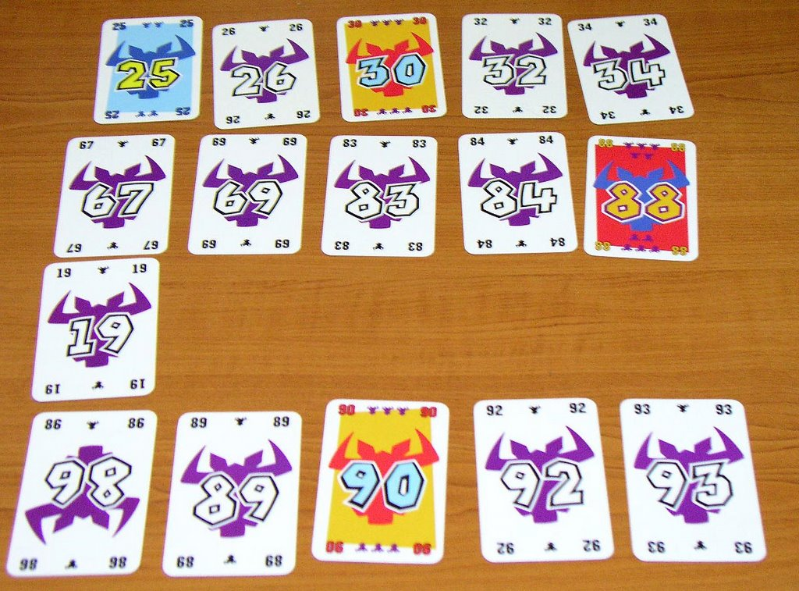

**Rules and game course:**

Each player receives ten cards at the beginning of the game. There are 4 cards placed on a table as a base of four raws. Each of these raws may contain no more than 5 cards during a game. Each player lays out one card face down on the table in front of himself. When everybody laid a card, the cards are turned at once. The player who landed the lowest card, places it first in one of the four raws, then the second lowest card is placed and so on. The rules for placing cards:

1. Ascending order of numbers in a row.
2. Smallest difference between the landed card and the last card placed in a row. In case you need to place a card that is less than the last cards in all rows, the player must take all cards from the raw of his choice and place her/his card as a new start of the raw.
3. Full raw consists of 5 cards. The player, who should place in such a raw the sixth card, (s)he has to take all 5 cards and place her/his card as a first card in new raw.

The game ends when all the cards are landed. Every player counts up all the cows on the cards in her/his pile. The results of all players are written on the paper and another round starts. We play until some player does not reach 66.

**Target group:** Primary school

**Practice:** arrangement of numbers to 104, numbers comparing, division

# http://www.100doblones.com/animacion/imagenes/sushizocktablero.jpgSushiZock im Gockelwok

**Number of players:** 2 – 5

**Tools:** *5* *playing dice*: each die has two walls with Sushi (blue), the two walls of the fish-bone (red) on one wall are blue chopsticks, and on one wall are red sticks, *24 stones*: 12 times Sushi (blue) from +1 to +6 points, 12 times fishbone (red) from -1 to -4 points.

**Aim:** To have the most points.

**Rules and game course:**

At the beginning of the game we place randomly stones with "Sushi" in one row and stones with "fishery bones" in the second row. Players throw the dice and try to collect the stones from the middle of the table. Each player can throw in her/his turn three times, but (s)he does not need to use all of them. After each roll at least one die must be put aside. When you finish your move, you can take the stone from the middle of the table that is in such position of how much sushi or fish bones are displayed on the dice. If the player cannot take off the table any stone, (s)he takes a stone with the lowest value. Players can also steal stones from opponent if there are 3 and more sticks of the same color. 3 sticks allow theft to steal the top stone from any opponent, 4 or 5 sticks will allow to steal any of the stones from opponent's piles (without viewing). After each turn, the player saves a stone in one of the two columns - one is blue, the second one is for red stones. End of the game comes when you run out of stones from the middle of the table. Players have to put aside all blue stones, which extend over the red stones and count the points.

**Target group:** Primary school

**Practice:** addition and substraction, negative numbers, estimation of probability, short term memory

# Mathematical Ludo

**Players:** 2 – 4

**Aids:** Ludo board, questions and logic riddles, Ludo pieces, die

**Aim:** Reach the “home fields” as the first

**Rules and game course:**

The rules are the same as the ones of classic Ludo game. However, they do not have to roll a six to start the game. Players roll die and they move their tokens forward along the track the number of fields indicated by the die roll. When the token is moved to coloured field, the player has to solve a task – he/she can´t move until he/she answer it correctly. The player (or a group) solves the task alone; no one can help him/her. He/she can ask teacher for help, but each help is penalized by moving 2 fields backward. If he/she doesn´t solve the task, the opponent on the right side receives his/her points for moving forward. If he/she solves the task correctly, he/she rolls the die again. The winner is the player who first reaches the “home fields” (or who is nearest to his/her “home fields). If the advance of a token finishes on a field occupied by an opponent´s token, both of them receive “shoot-off” question. The first, who correctly answer the question, stays on the field, the other one has to return to his/her owner´s yard. If players disturb the game or they do not respect instruction, they receive penalty - they have to move 5 fields backward – (teacher or controller penalizes).

**Target group:** upper secondary education

**Modifications:** After changing question, teachers can play the game with pupils of primary and lower secondary education.

**Practice:** logical thinking, different mathematical themes

Tasks (coloured field of the board):

1. Father has got three daughters; each of them has one brother. How many children does father have?
2. Solve equation 
3. Find Cartesian coordinate of vertex of 
4. Solve inequation: 
5. Sketch the graph of function: 
6. A girl drove geese to pasture. One went before two geese; one went between two and one behind two. How many geese does the girl have?
7. Solve equation: 
8. Find Cartesian coordinate of vertex: 
9. Solve equation: 
10. Sketch the graph of function: 
11. Which number is larger by 3 when we turn it upside down?
12. Solve equation: 
13. Find Cartesian coordinate of vertex: .
14. Solve inequation: 
15. Sketch the graph of function 
16. One brick weights 1 kilogram and a half of a brick. How many kilograms do two bricks weight?
17. Solve equation: 
18. Find Cartesian coordinate of vertex 
19. Solve inequation: 
20. Sketch the graph of function 

“Shoot-off” tasks:

1. Which mathematical symbol should we put between numbers 5 and 9 to have a number greater than 5 and smaller than 9?
2. How many times can we deduct two from thirty-two?
3. In the candy shop, the small ice cream (1 scoop) costs 0,50 €, the big one (2 scoops) costs 1€. Two girls enter the shop. Petra puts 1€ on a counter and an ice cream man gives her a big ice cream without asking anything. Then Daniela puts 1€ on the counter, but the man asks her if she wants a small one or a big one. He doesn´t know the girls. Why does he ask Daniela if she wants a big one or a small one, although both girls put the same amount of money on the counter?
4. How many eggs could you put into an empty basket?
5. What is heavier? A kilogram of iron or a kilogram of feather?

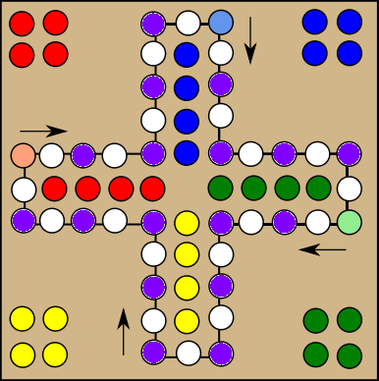

# Ludo with Multiplication

**Number of players:** 2 – 4

**Tools:** board, Ludo pieces, die and premium tasks

**Aim:** reach the field “finish”

**Rules and game course:**

Each player rolls the die and the highest roller begins the dame. The players alternate turns in an anti-clockwise direction. Players do not have to wait until they throw a six (as in classic Ludo game). Player moves his/her token forward along the track the number of fields indicated by the die roll.   
If player moves his token on multiple of

* 7, he/she rolls again and moves his/her token backward along the track the number of fields indicated by the die roll,
* 8, he does not roll the die in the next turn,
* 9, he/she rolls again and moves his/her token forward along the track the number of fields indicated by the die roll.

When the number is divisible by two divisors (7, 8 or 9), he plays according instruction for a bigger multiple.

If player moves his/her token on a green “premium” field, he/she takes a premium task. In the case of correct answer he/she moves two fields forward; in the other case he stays at his/her position.

If the advance of a token finishes on a field occupied by an opponent´s token, the player does a swap with an opponent. (For example: player 1 is on a field 29 and player 2 on a field 27. The player 2 rolls a two, so players do a swap – player 1 is on a field 27 and player 2 on a field 29.)

**Target group:** primary education, lower and upper secondary education

**Modifications:** Premium tasks could be changed and adapted for different fields of mathematics.

**Practice:** multiples, selected topics

# Mathematical Memory Game

**Number of players**: 2

**Tools:** cards with numbers from 1 to 9, table with 30 fields (6 x 5), where each field contains different multiples of two natural numbers from 1 to 9.

**Aim:** Having 4 marks in one column, row or diagonally.

**Rules and game course:**Before the game starts, all cards with numbers are laid face down on a surface. Players decide which one starts. In turn each player chooses two cards and turns them face up. (S)he multiplies these numbers and marks the product in the table by his/her mark (colour, cross/circle). Then the cards are turned face down again and play passes to the next player. The game ends when one of the players has 4 his/her marks in one column, row or diagonally. If the field is already occupied, it can´t be marked by an opponent.

**Target group**: primary and lower secondary education

**Modifications:** We can choose number of cards or mathematical operation

**Practice:** multiplication, strategic thinking, concentration, memory

# Math Dobble

**Number of players:** 1-3

**Tools:** 13 cards (on each of the cards are illustrated 4 expressions of the length or the volume)**.**

**Aim:** to get the most of the cards.

**Rules and game course:**

Any two arbitrary cards have exactly one common symbol. Each of the symbols occurs at least on two cards. There are several ways to play this game. In original game it is important who first finds and names the common symbol. We have prepared a set of 13 cards with the theme the measure conversion. Unlike in the original game, in our variation the players are not looking for the same symbols, but different expressions of the same length, respectively the volume.

At the beginning of the game, one card is put face down in front of the each player. Other cards are put into the middle of the table facing up. At the same moment, all players turn their card face up and then look for the same expression of one of the lengths (or one of the volumes), on their card and the top card in the middle of the table. The first one who spots and names the common expression of the length (or the volume) gains the top card and puts the gained card aside. The game continues until all the cards, situated in the middle of the table, are run out of.

**Target group:** Secondary school students.

**Modifications:** To add variety to the mathematics lesson, it is possible to create own playing cards based on the Dobble principle. The used symbols can be mathematical concepts or geometrical shapes that we want to practice.

**Practice:** perception, mathematical concepts**.**

**The mathematical background of the game Dobble:**

In the core of the design of this game is mathematics. Problem of finding the largest card system with *n* symbols on each card with as few different symbols as possible in such a way that each two cards have exactly one common symbol, is the problem analogous to the structure of the final projective plane of the order *n-1*. The maximum number of different cards is *n2+n+1*, the minimum number of different symbols is also number *n2+n+1*.

The original game Dobble corresponds to the final projective plane of the order 7 (whereas there are 8 symbols on one card). Thus, the minimum number of different symbols is 57 and the game can be of a maximum of 57 cards.

Ideas for tasks:

1. Find two cards which could be inserted into a set of the cards accordingly.
2. Determine the minimum set of cards which can be used to reconstruct other sets.

See the table below to design your own sets of cards.[1] S1, S2, ..., S13 represent different symbols, C1, C2, ..., C13 represent cards, “+” means that the symbol is present on the particular card. Thus on the card 1 (C1) are symbols S1, S2, S3, S4, on the card 2 (C2) are the symbols S1, S5, S6, S7, etc..

|  |  |  |  |  |  |  |  |  |  |  |  |  |  |
| --- | --- | --- | --- | --- | --- | --- | --- | --- | --- | --- | --- | --- | --- |
|  | S1 | S2 | S3 | S4 | S5 | S6 | S7 | S8 | S9 | S10 | S11 | S12 | S13 |
| C1 | + | + | + | + |  |  |  |  |  |  |  |  |  |
| C2 | + |  |  |  | + | + | + |  |  |  |  |  |  |
| C3 | + |  |  |  |  |  |  | + | + | + |  |  |  |
| C4 | + |  |  |  |  |  |  |  |  |  | + | + | + |
| C5 |  | + |  |  | + |  |  | + |  |  | + |  |  |
| C6 |  | + |  |  |  | + |  |  | + |  |  | + |  |
| C7 |  | + |  |  |  |  | + |  |  | + |  |  | + |
| C8 |  |  | + |  | + |  |  |  | + |  |  |  | + |
| C9 |  |  | + |  |  | + |  |  |  | + | + |  |  |
| C10 |  |  | + |  |  |  | + | + |  |  |  | + |  |
| C11 |  |  |  | + | + |  |  |  |  | + |  | + |  |
| C12 |  |  |  | + |  | + |  | + |  |  |  |  | + |
| C13 |  |  |  | + |  |  | + |  | + |  | + |  |  |

See the table below for the preparation of the game with 5 different symbols on each of the cards. According to the theory, the set must consist of 21 cards and 21 different symbols.[2]

|  |  |  |  |  |  |  |  |  |  |  |  |  |  |  |  |  |  |  |  |  |  |
| --- | --- | --- | --- | --- | --- | --- | --- | --- | --- | --- | --- | --- | --- | --- | --- | --- | --- | --- | --- | --- | --- |
|  | S1 | S2 | S3 | S4 | S5 | S6 | S7 | S8 | S9 | S10 | S11 | S12 | S13 | S14 | S15 | S16 | S17 | S18 | S19 | S20 | S21 |
| C1 | + | + | + | + | + |  |  |  |  |  |  |  |  |  |  |  |  |  |  |  |  |
| C2 | + |  |  |  |  | + | + | + | + |  |  |  |  |  |  |  |  |  |  |  |  |
| C3 | + |  |  |  |  |  |  |  |  | + |  |  |  |  | + | + | + |  |  |  |  |
| C4 | + |  |  |  |  |  |  |  |  |  | + |  | + |  |  |  |  | + |  | + |  |
| C5 | + |  |  |  |  |  |  |  |  |  |  | + |  | + |  |  |  |  | + |  | + |
| C6 |  | + |  |  |  | + |  |  |  | + | + | + |  |  |  |  |  |  |  |  |  |
| C7 |  | + |  |  |  |  | + |  |  |  |  |  |  |  | + |  |  | + | + |  |  |
| C8 |  | + |  |  |  |  |  |  | + |  |  |  |  | + |  |  | + |  |  | + |  |
| C9 |  | + |  |  |  |  |  | + |  |  |  |  | + |  |  | + |  |  |  |  | + |
| C10 |  |  | + |  |  | + |  |  |  |  |  |  |  |  | + |  |  |  |  | + | + |
| C11 |  |  |  |  | + | + |  |  |  |  |  |  |  | + |  | + |  | + |  |  |  |
| C12 |  |  |  | + |  | + |  |  |  |  |  |  | + |  |  |  | + |  | + |  |  |
| C13 |  |  | + |  |  |  | + |  |  | + |  |  | + | + |  |  |  |  |  |  |  |
| C14 |  |  | + |  |  |  |  | + |  |  |  | + |  |  |  |  | + | + |  |  |  |
| C15 |  |  | + |  |  |  |  |  | + |  | + |  |  |  |  | + |  |  | + |  |  |
| C16 |  |  |  | + |  |  | + |  |  |  |  | + |  |  |  | + |  |  |  | + |  |
| C17 |  |  |  |  | + |  | + |  |  |  | + |  |  |  |  |  | + |  |  |  | + |
| C18 |  |  |  |  | + |  |  | + |  | + |  |  |  |  |  |  |  |  | + | + |  |
| C19 |  |  |  | + |  |  |  |  | + | + |  |  |  |  |  |  |  | + |  |  | + |
| C20 |  |  |  |  | + |  |  |  | + |  |  | + | + |  | + |  |  |  |  |  |  |
| C21 |  |  |  | + |  |  |  | + |  |  | + |  |  | + | + |  |  |  |  |  |  |

The sources which has inspired us:

<http://eliacalderan.wordpress.com/2012/11/12/dobble-visto-da-un-matematico/>

<http://bowmandickson.com/2012/07/15/math-circle-problem-analysis-of-the-game-spot-it/>

# Catch Me!

**Tools:** 5 wooden blocks with geometric figures, 120 playing cards (two geometrical shapes of different colors are on each card)

**Aim:** Get the most cards.

**Rules and game course:**

We have 5 colors and 5 geometric shapes. We draw one card and the players are trying to catch blocks by type of card. Who grabs the first block with wanted shape, gains the card. If there is the shape with correct color, the goal is to grab the block with its shape. If there is no shape in the correct color, the goal is to grab the block with the shape, which is not present on the card is nor by color, nor by shape.

**Target group:** Primary school students.

**Modifications:** Objects can be adapted to the current topic being acquired, for example, we can:

* create color objects and color cards containing equations to calculate their volume,
* sketch graphs of functions and indicate their prescription on a card, or characteristics,
* write colored Roman numerals and on the card Arabic numerals (or vice versa).

**Practice:** names of shapes, logical thinking

# http://ecx.images-amazon.com/images/I/51J8n9NcmwL._SY300_.jpgSwish

**Number of players:** 1 – 6

**Tools:** 60transparent cards

**Aim:** Get the most cards.

**Rules and game course:**

16 transparent cards are laid on a table at the beginning of a game​​. Each card has one spot and one ring. Players look for "Swish", what is a pair, trio, quartet, ..., or duodecad cards so that after laying these cards, they fit together - dots in circles with the same color. The player who sees "Swish" shouts "Swish!" And (s)he shows the cards that it consists of. If proved correct, (s)he takes the cards. If (s)he made ​​a mistake, (s)he must pass one card from her/his pile. Cards can be rotated and spinned, and any dot or circle cannot be left without a "partner". Cards are still being laid, until all run out, then the game is over.

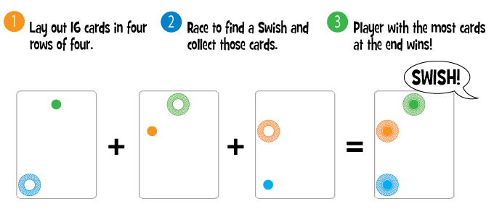

**Target group:** All age groups.

**Modifications:** With older students we can analyze the mathematical background of Swish game - what congruent mapping o we use looking for Swish? Which cards are axially symmetrical? Are there some, which are centrally symmetrical? Are there any card pairs of centrally symmetrical?

**Practice:** spatial imagination, congruency

# http://www.stragoo.cz/content/gallery/25f55537-fcac-44e3-845e-8db888502a4e.jpgContinuo

**Number of players:** 1 – 5

**Tools:** 42 cards divided into 16 coloured squares

**Aim:** Get as many points as possible by creating the longest chain of squares with same colour.

**Rules and game course:**

The game begins by placing 1, 2 or 3 cards on the table, depending on the number of players (everyone has to have the same number of moves). Players attach one card to form the longest chain of squares of the same color. For each square in the string player gains one point. In one turn you can create even more chains. The game ends after placing all the cards, the player with the highest score wins.

**Target group:** All age groups.

**Practice:** addition, multiples of 3, divisibility, strategic thinking, logical thinking

# Grabolo

**Number of players:** 3 – 5

**Tools:** 36 color cards with numbers from 1 to 6, 1 dice with numbers or dots, 1 dice with colored walls.

**Aim:** to get the number of cards that is prescribed

(3 players - 10 cards, 4 players - 8 cards, 5 players - 6 cards).

**Rules and game course:**

At the beginning of the game all cards are shuffled and spread out on the table face up. The move is to roll two dice (one indicates a color, the second indicates the number on the card). All players try lay her/his hand on the right card as soon as possible. Whoever is the first, takes a card and places it face down in front of herself/himself. In the case that the searched card is on a pile of any player, they all try to guess who is it. Applies the tip, which is said first. If that is correct, the player can take the card. If the tip is wrong, the player who guessed must put one of her/his cards on the table face up to other cards. If no one shouts the tip, the game continues and another player throws the dice. When a player obtains a prescribed number of cards, the game ends.

**Target group:** Primary school pupils.

**Modifications:** With older pupils of we can discuss the number of cards in the case that we play the game Grabolo with two dice (1 numeric, 1 color), three dice, etc.

**Practice:** colours, numbers from 1 to 6, memory

# Scopa

**Number of players:** 2 – 4

**Tools:** 40 cards (with values from 2 to 10 and aces)

**Aim:** Be the first to get 11 points.

**Rules and game course:**

One player is the dealer (deals the cards). Dealer puts 4 cards to the center of the table and then deals 3 cards to each player. The game begins with the player on the left from a dealer. A player in charge may:

* 1. take a card from the middle of the table with the same value (s)he has in hand and put both aside;

1. take a pair or triple of cards from the middle of the table, the sum of which equals the value of one of the cards you have in hand;
2. put one card from hand to the middle of the table next to other cards (if you cannot do either a) or b)).

The player, who takes the last card from the center, gains 1 point, the next player must lay out one card into the middle of the table. When players have no cards, the dealer deals 3 cards to everyone and again the player on the left side of the dealer starts. Round ends when players have no cards and the dealer has no more to deal. The player who took the last card from the center possesses all the cards left in the middle of the table.   
After finishing the round, the points are summarized:

* 1 point for the player possessing diamond seven;
* 1 point for the player possessing the most from the diamond cards (If several players have the same number, nobody scores a point);
* 1 point for the player possessing the most number of cards (If several players have the same number, nobody scores a point);
* 1 point for the player possessing the biggest ‘Primiera’ (If several players have the same number, nobody scores a point)
  + To count ‘Primiera’ every player picks one card from every suit and sums their values:
    - seven = 21;
    - six = 18;
    - ace = 16;
    - five = 15;
    - four = 14;
    - three = 13;
    - two = 12;
    - ten, nine, eight = 10.

After finishing a round and counting points the next player becomes the dealer and starts the next round.

**Target group:** Children of all age groups.

**Modifications:** Divisibility – discussion on the number of cards and the appropriate number of players (Why do all the players always get the same number of cards? How many players could play this game if it was played with *x* cards?).

**Practice:** strategic thinking, addition, logical thinking, memory

# Game Tips

Qwixx <http://www.ihrysko.sk/hry-na-party/qwixx.html?page_id=9498>

20 Express <http://www.blueorangegames.com/index.php/games/20express>

Superfarmár <http://www.granna.sk/detail-hry.php?hracka=24>

Rummikub <http://www.dracik.sk/hra-rummikub-2/>

Kočka v pytli <http://www.deskovehry.com/s-pribehem/430/recenze-felix-kocka-v-pytli/en>

Heckmeck <http://www.hrajeme.cz/hrajeme/GameDetail.aspx?id_hry=1429>

___________________________________________________________________________

___________________________________________________________________________

___________________________________________________________________________

___________________________________________________________________________

___________________________________________________________________________

___________________________________________________________________________

___________________________________________________________________________

___________________________________________________________________________

___________________________________________________________________________

___________________________________________________________________________

___________________________________________________________________________

___________________________________________________________________________

___________________________________________________________________________

___________________________________________________________________________

___________________________________________________________________________

___________________________________________________________________________

___________________________________________________________________________

___________________________________________________________________________

___________________________________________________________________________

___________________________________________________________________________

___________________________________________________________________________

___________________________________________________________________________

___________________________________________________________________________

___________________________________________________________________________

___________________________________________________________________________

___________________________________________________________________________

___________________________________________________________________________

___________________________________________________________________________

___________________________________________________________________________

___________________________________________________________________________

___________________________________________________________________________

___________________________________________________________________________

___________________________________________________________________________

___________________________________________________________________________

___________________________________________________________________________

___________________________________________________________________________

___________________________________________________________________________

___________________________________________________________________________

___________________________________________________________________________

___________________________________________________________________________

___________________________________________________________________________

___________________________________________________________________________

___________________________________________________________________________

___________________________________________________________________________

___________________________________________________________________________

___________________________________________________________________________

1. Based on the article <http://en.wikipedia.org/wiki/Projective_plane>
2. Source <http://www.uwyo.edu/moorhouse/pub/planes/>.